**Project Design Phase-I**

**Solution Architecture**

|  |  |
| --- | --- |
| Date | 19 september 2022 |
| Team ID | PNT2022TMID38557 |
| Project Name | IOT Based smart crop protection system for agriculture |
| Maximum Marks | 4 Marks |

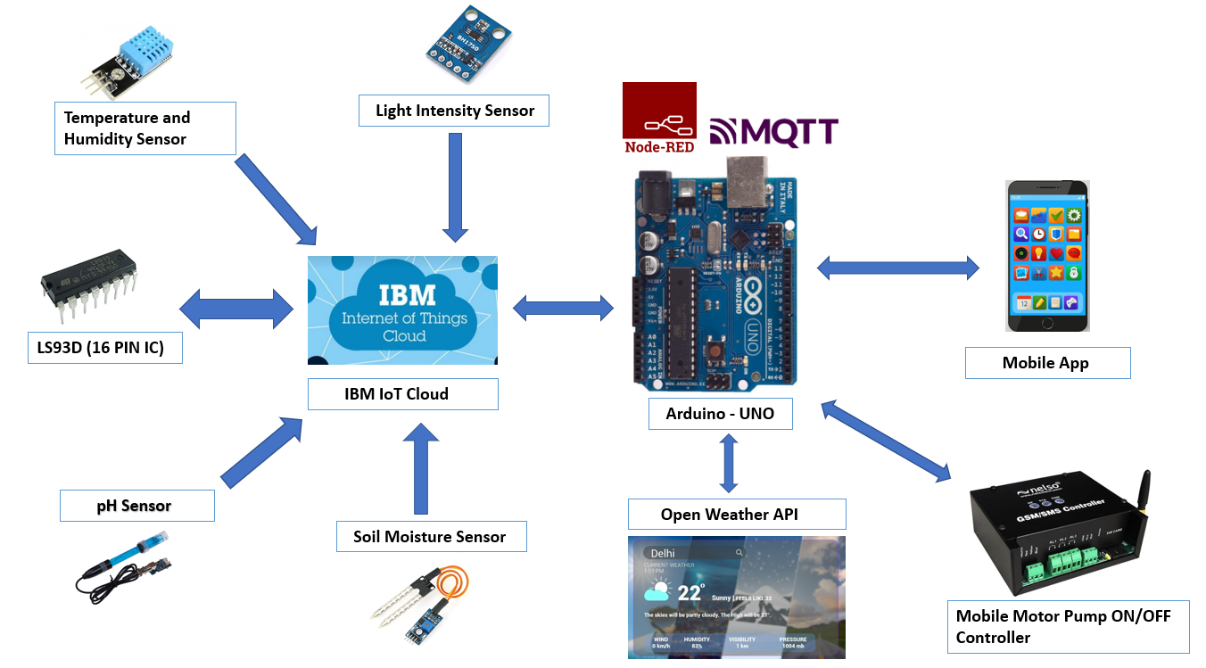

Key points:

•  The different soil parameters (temperature, humidity, light intensity, pH level) are sensed using different sensors and the obtained value is stored in IBM cloud.

•  Arduino uno is used as a processing unit which processes the data obtained from sensors and weather data from weather API.

•  Node red is used as a programming tool to wire the hardware, software and APIs. The MQTT protocol is followed for communication.

•  All the collected data are provided to the user through a mobile application which was developed. Depending upon the sensor values, Mobile Motor Pump controller waters the crop